Theory and Experimentation

Sections : Introduction, Definitions, Background, Validation, Experiments, Motivation

Intro

We most likely come back and finish this section from Tuesday, as its most relevant for the presentation. Check the motivation section for a kinda intro.

first plants
modern day changes is accelerated morphological evolution
bio and geo diversity is inherently important in itself (references)
this river is one of the last left,

Definitions

Channel Type - Depends on stream gradient, riparian vegetation and sediment supply.

See “Sorting out river channel patterns (2010) Progress in Physical Geography – M. Kleinhans” for a decent overview.

Anastomosed – Often confused with braided. A type of river with multiple, interconnected, coexisting channel belts on alluvial plains. They distinguish themselves by a dense network of belts of variable width and length which by turns split and join.

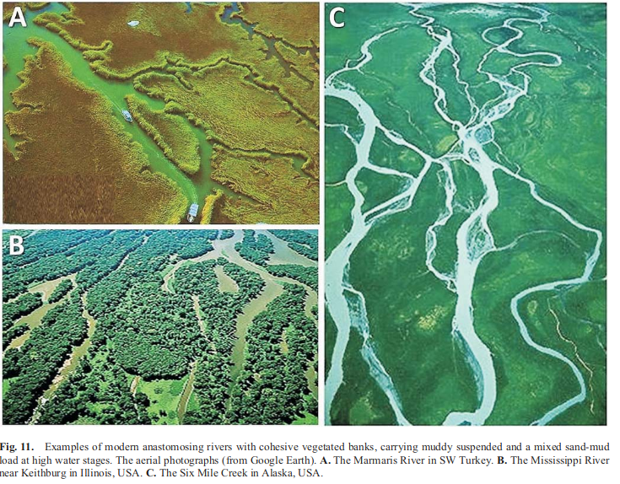

See -Anastomising rivers: a review of their classification, origin and sedimentary products (2000) Makaske. - for a comprehensive review. Would recommend at least one of you have a flick through this one … Although a lot of it is covered in the Background section below.

Braided river – Characterised as having lots of relatively small channels that frequently diverge and reconnect. Channels are shallow and migrate laterally relatively rapidly, and the slope is generally quite high. Larger sedimentary load than the discharge of the river.

Meandering river – Only emerged once land plants evolved complex root systems that were able to stabilise soils. Usually occur at the low-gradient plain towards the end of the system. The situation is very different in a non, or poorly vegetated environment. Here, the river can rapidly erode away its river banks so it is very easy for the river to spread horizontally, frequently forming new channels and migrating laterally over time.

Straight (single channel) – Very few found in nature. (1) On the two banks there are materials with higher stability such as outcrop of rock, clay sediments and dense vegetation and so on which will confine the channel lateral migration. The straight channel planform under these conditions maintains chronically (Like our first experiment) (2) Temporarily formed straight channel during the development of meandering river. This straight channel has some stability and its planform may change or disappear during the channel migration. (3) In river delta areas there are straight channel planforms which have higher stability because thick clay sediments in banks confine channel lateral migration. - Qain N, 1985. On the classification and causes of formation of different channel patterns. Aeta Geographica Sinica, 40(1): 1-10. (in Chinese) Qian N, Zhang 1L Zhou Z, 1987. Channel Bed Evolution. Beijing: Science Press, 584.
- Straight river: its formation and speciality : Wang and Ni (2002)

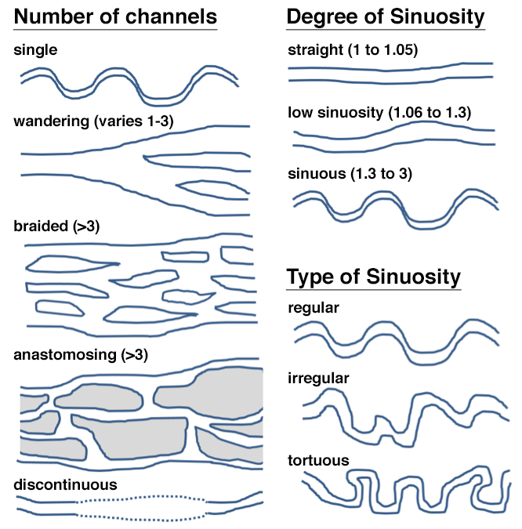

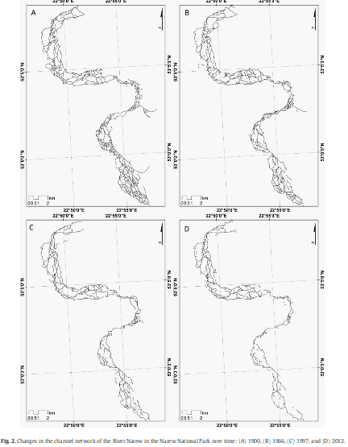
River Narew - The hydrological regime of the River Narew manifested itself by long lasting flooding and additional intensive inundation by shallow groundwater. The Narew is a lowland low-energy river in northeastern Poland (Fig. 1). It drains an area of 75,000 km2, partly located in Belarus, and is a right-hand tributary of the largest river in Poland, the Vistula. The catchment is located in a temperate climatic zone with moderately warm summers (mean temperature in July 18°C), cool winters (mean temperature in January -2ºC), and an annual average precipitation total of ca. 600 mm.- Marcinkowski et al (2018) Where might the hands-off

Last 100 years of change. See for higher resolution - Controls on anastomosis in lowland river systems: Towards process-based solutions to habitat conservation (2017) – Marcinkowski et al.

Riparian zone/area – The interface (transitional area) between land and the river. Usually aquatic plants or on the banks of the stream. These zones dissipate stream energy. Meanders combined with vegetation and root systems, slow the flow of water, reducing soil erosion and flood damage.
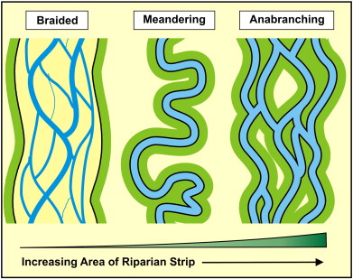

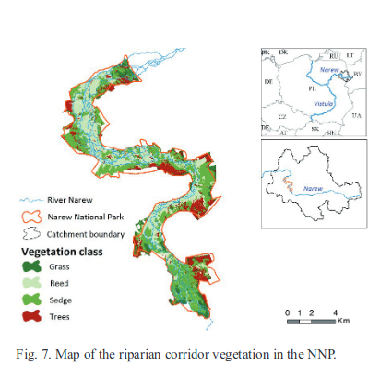

Notice how the trees cause the overall rivers shape to meander!
-from the hands- off paper
Marcinkowski et al (2018)

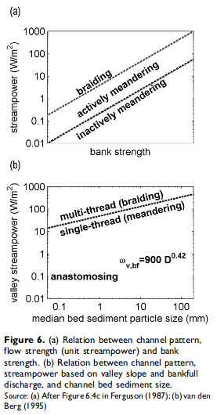
Sediment Supply – We haven’t thought about this much but this could have a big effect !! Easily modeled with higher sedimentation rates. Overloading a river with more sediment than transport capacity may result in braiding whereas reduced load may result in meandering. (Church, M. 2006: Bed material transport and the morphology of alluvial river channels. Annual Review of Earth and Planetary Sciences 34, 325–54).

Humans and Settlements -
- Hunter-gatherer: minimal effect
- Early Civ-
- Medieval – Water used as defense, extensive managed forestry, agriculture in floodplains, fords and bridges, milling, building, canalisation,
- Industrialisation

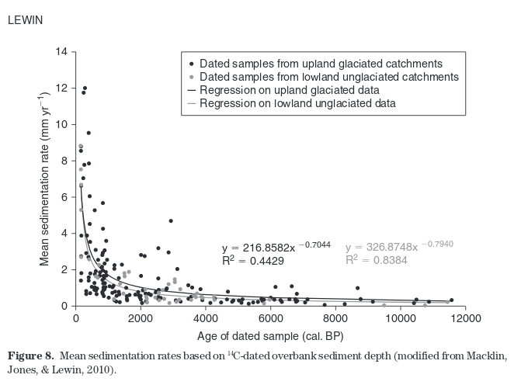

SEDIMENTATION RATE GETS HIGHER OVER HISTORY EXPONENTIALLY exponential/power law

Background

Anastomosing rivers are interesting dynamic system created as a result of interaction between
constructive and destructive processes. Anastomosing systems are formed in middle part of
river system. Slope on these area is very small — approximately 10cm per 1km. Flow rate
is also very small, river do not erode terrain. Organic and non-organic materials carried by
river are mostly transported through this part of river and deposited later in lower reaches.
Waters rich of nutrients penetrate soil in surrounding banks. Fertile areas near river channels
are characterized by a signiﬁcant increase in vegetation. Products of plant decay deposit on
this area as peat (approximately 1-1.5 mm/year Gradzinski et al. (2003)). Peat accumulation
lasting for thousands years may produce a peat bog with a depth of several meters. - Network_Systems_Modelled_by_Complex_Cellular_Automata_Paradigm - Pawel

“Anastomosing rivers were historically common around the world before agricultural and industrial development in river valleys.” (LEWIN J. Medieval environmental impacts and feedbacks: The lowland floodplains of England and Wales. Geoarchaeology-an Int. J. 25, 267, 2010 )

“Since the vast majority of anastomosing rivers are morphologically quite similar, they can be considered as an example of an equifinal system, i.e., different combinations of processes or causes produce a similar form” (MAKASKE B. Anastomosing pattern. Encyclopedia of Planetary Landforms, 1, 2014)

“Schumm (1985) put more focus to the channel lateral stability and categorized both braided and meandering rivers as laterally unstable and bedload-dominated. It was also pointed out earlier by Schumm (1968) that the use of the terms ‘braided or braiding’ and ‘anastomosed or ‘anastomosing’ as synonyms is incorrect, because these channel patterns represent different types of river behaviour. Smith and Smith(1980) defined an anastomosing river as ‘an interconnected network of low-gradient, relatively deep and narrow, straight to sinuous channels with stable banks of fine-grained sediment and vegetation’. Nanson and Knighton (1996) had similarly classified anastomosing rivers as a specific variety of a broader category of anabranching rivers, characterized by laterally stable multiple channels irrespective of their sinuosity. It is now also widely recognized that an anastomosing river system requires cohesive and/or densely vegetated, relatively stable channel banks (e.g., Rust, 1981; McCarthyet al., 1991; Gibling et al., 1998; Gradziñskiet al.,2000; Gruszka and Zieliñski, 2008; Grosset al., 2011). - Widera, M., Kowalska, E. & Fortuna, M., 2017. A Miocene anastomosing river system in the area of Konin Lignite Mine, central Poland.Annales Societatis Geologorum Poloniae, 87: 157–168

Validation

We could (conceptually/theoretically) validate our model by replicating the conditions that create the types of river structure known (i.e. meandering rivers need plant structure, human river control stops braided rivers, etc …)

From Least Comprehensive to Most

- Anastomosation of any kind (already acheived)
- River Narew’s general structure (partially (fully?) achieved)
- Show that the model can recreate other river types (such as single channel, meandering, braided rivers, etc.) when parameters are altered to model different scenarios
  - A very steep terrain may create a single channel?
  - High water flow from source node floods system or single channel?
  - The major problem here is that this model was only designed to replicate anastomosing rivers and therefore does NOT explicitly consider “sinuosity” or erosion. However, if you have a look at the definitions of these river types and implement them I reckon it might actually work. Turns out single channel only really occurs in part or where there are outcrops of high stability either side.
- Further validation starts to blur the line between hypothesis and experiment so will be covered in those sections.

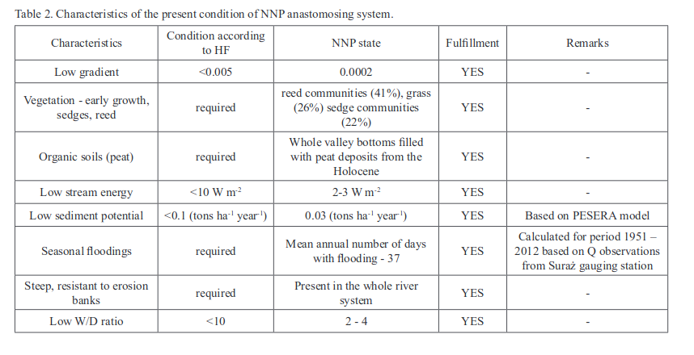
-From hands off paper again , this is at PRESENT in the river narew, - Marcinkowski et al (2018)

river-width/river-depth ratio (W/D)

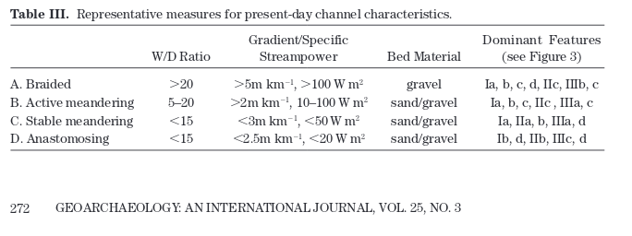
from medieval environmental impacts paper – Lewin (2010)

Experiments

My memory is a bit shit, so if you can remember any experiments we have talked about (especially with Rick) add them here. I remember him talking about adding drains, settlements, how many river branches exit the screen (increase water flow or another parameter, measure this and graph it), finding emergent properties (and the phase transitions that create them). The most essential way our model is related to complexity, will be via control/order parameters and the macroscopic behaviours they induce.

1. The First Plant(s)

- We could use the terrain height as a proxy for carboniferous growth.
- Super growth peat (after enough has built over a long enough period?)

2. Effects of Settlements

- We could use terrain as a proxy for urban settlement or river protection (i.e. industrial areas cannot have water displaced to them) we can then analyse how urban development affects river flow.

3. Ice Ages

- self similar – branching process with stotrms – sandpile model- rainfall and storms winter melts

Motivation: Motivate the work - understand why the simulation/experiments are of interest

modern day changes is accelerated morphological evolution
bio and geo diversity is inherently important in itself (references)
this river is one of the last left,

- Variable rainfalls, snow melts, disordered weather patterns, dam removal, dam creation, nitrogen flux, city/town planning (sustainability), climate/ecological change,

- Methodologically applies to several cutting edge poorly understood phenomena (e.g. angiogenesis, plant root formation).

- Very similar patterns are found in lava flows, outflow channels (Found on Mars and Venus)

- “However, a small number of studies reported worldwide until nowadays and studies evidencing their extinction [13-14] might lead to the conclusion that only several anastomosing systems remain worldwide and a special focus on their investigation is highly required” – Hands off paper

- Anastomising rivers are SENSITIVE to climatic or tectonic forcing - frequent channel avulsions due to the increased frequency of floods, rise of base level, and/or sediment overloading - Electrical resistivity imaging of anastomosing river subsurface stratigraphy

